Statement of Needs

Introduction

All Saints is proposing to undertake a Reordering of the Church. We believe this is critical to achieving our vision of “Be Family, Make Disciples, Serve Others,” and as we go into the future to be a church that supports and is integrated into the local community. We see our church as a living building that throughout its 1100-year history has adapted to help fulfil its task of enabling us to worship the Living God. Our Reordering proposal represents the next phase of the Church’s journey to support worship in the 21st century.

General Information

All Saints serves the Parish of Northwest Swindon and Lydiard Millicent. The village itself has a population of 1570 (in 2011) with 4,600 in the wider parish which includes parts of Northwest Swindon (Peatmoor and Sparcells). Our Electoral Role is currently 92 people.

We currently have the following services and events, which are much reduced since the onset of the Covid 19 pandemic. However, we fully anticipate that we will be able to significantly increase our engagement with all sectors of the community (Christian and secular) as the pandemic recedes. For example, the School Worship Committee is now coming to the church each month to help us review our reordering plans and share their ideas. RE classes at church will start again soon and we have numerous other ideas to engage with the communities around us.

Worship

Service | Frequency | Location | Number of Congregants
Sunday
08:00 Service | Weekly | Church | 10 to 12
10:30 Morning Worship or Holy Communion | Weekly | Church | 45 to 65
Monday
Prayer Meeting | Weekly | Church | 6 to 10
Thursday
10:00 Holy Communion | Monthly | Church | 10
Annual
Staycation Friday to Sunday | Annual | Lydiard Millicent School | 60

Baptisms, Weddings and Funerals

Service | Number Held | Notes
Baptisms | 11
Weddings | 4
Funerals | 10

Teaching

Course | Frequency | Location | Attendees
Alpha | Every Year (run annually for 10 weeks) | Host’s home | 8 Adults
House Groups | Monthly | Host’s homes | 8 Adults
Mens breakfast | Monthly | Vicarage | 8 adults
Church open for quiet prayer | Weekly on Wednesdays | Church | 4 adults
Safeguarding | On demand, usually at least annually | Church | Up to 25 including people from other churches
The Bible Course | Weekly runs for 10 weeks | Vicarage | 10 to 12 Adults
Marriage Course | 4 per year, aligned with Weddings | Vicarage | 2 Adults

Schools

All Saints works closely with local schools within the Parish, in particular Lydiard Millicent Church of England Primary School and the recently opened Ridgeway Farm Church of England Academy.

An “Open the Book” team are based in this parish and use the church monthly to film their YouTube services which go out across Swindon

Services run for local schools include Christmas, Easter, and Harvest. In addition, we also work closely with Year 6 Leavers and lead a number of Religious Education lessons including mock Wedding, mock Funeral, the role of a Vicar, Experience Easter, Pentecost as well as explaining Holy Communion and Baptism. We have annual prayer events and displays that the schools attend and participate in. We are involving the Worship Committee of our local school in the final planning details of the project.

We envisage that a reordered church with more flexibility to adjust layout, seating etc will allow us to provide a more positive and effective environment for our partner schools, encouraging use for teaching, prayer, and learning.

Links to other Churches

We have a close relationship with a number of other local churches. During the pandemic, we held a joint Alpha course online with Pattern Church (3.5 miles away in Central Swindon) and we both valued working together. We have also created a Puppet Show jointly with Freshbrook Church (in West Swindon), practicing this together at our Church before we put on a production in a local school. We would like to do more such joint activities, not just with Pattern Church and Freshbrook Church but with others we know well, ideally face-to-face.

Several of the local churches around us are constrained by their buildings, in the Christian activities they can offer. One for example is using the basement of an old building, another meets in a school. We would love to be able to bring local churches together, at All Saints for Christian teaching, worship, study, dance, drama and much more and so support, strengthen and encourage each other. Our building just doesn’t allow this at present, but it could, if reconfigured into a flexible, warm, light-filled space that is fully accessible, and where we could offer hospitality.

What do we need?

Why Reorder? Because the Core mission of the church is to worship the Living God. So primarily the building entrusted to us (not our building) needs to be fit for purpose. This means it needs to be a house of God in which people sense the transcendent nature of the triune God and can worship in that building effectively. Light, visibility, access and a floor space which allows flexibility of worship is critically important. Equally important is to be a place of hospitality that is warm and offers refreshment and comfort both physically as well as spiritually.
Our vision is to Be Family, Make Disciples and Serve Others.
Families change and grow, babies appear, others get older and need more comfort, young people want to be able to worship in more physically expressive ways (so do older people!). Families make their houses warm in winter, and cool in summer, a welcome place, and a place where young and old are safe and where hearing, seeing, walking, sitting, etc are all easily done.
Discipleship for us means constantly seeking to follow the teachings and example of Christ. We are a learning community and there are many different interactive ways in which we can learn and reach out to others to help them to understand Christianity. We would love to be able to offer a range of activities, such as; Christian speakers, drama, music groups, dance performances, bible studies, prayer, and healing events and additional RE lessons for schools. Unfortunately, however, All Saints as it is now configured, is not at all flexible. If we try to hold events in the church e.g., conferences, training, Alpha, joint meals, etc the pews present a real challenge as they hinder people from being able to interact with each other, the building can be dark and cold, and people need to find their way outside and round an outside path to use the lavatory.
Every year we hold our church ‘Staycation,’ a weekend aimed at getting to know one another, creating opportunities for the community to participate as well as worship and teaching. Due to the inflexible layout of the church, this is run at our local school as we cannot run a broad range of different sessions with pews; for example, eating a communal dinner, running a quiz night, teaching and most importantly praise and worship. In the school setting we change the layout to suit our needs over the weekend sometimes 3 or 4 times a day, this is simply not possible with our current configuration.
Serving others is a core value for us and we would love to be able to share the church as a resource with the local community more than we do now and put it in its rightful place at the heart of Village and Parish life. We have many groups that extend the role of the church into the community. Currently, the pews limit the number of people we can welcome in the church as there is very limited space, we are constrained to the aisles and creche area. In addition, the church does not have any kitchen/servery facilities and so we are restricted in the food we can offer.
Our Accessibility survey, to which sixty-two members of the congregation responded, has shown that there is a desire for greater flexibility, improvements in accessibility in terms of light, heat, comfort, hearing, etc Many of the comments addressed the way we are limited in the use of the building, such as meetings, worship styles, provision for children and young people and welcoming entrance.
We have two regular members of the congregation who find our current restrictions a significant challenge. Also, the current situation is likely to deter any new people from attending the church as it is such a difficult environment for those with specific access needs. In addition, the heating system in the church is old and very inefficient by modern standards. It is becoming increasingly difficult and costly to maintain as parts are less available and difficult to source. We would ensure that our Reordering project fully support the Diocese commitments to reducing carbon footprints.

The proposals

We have identified, initially, the following to meet the needs set out in section 3:

- Seating: All pews (other than the two choir stalls), to be removed and replaced with good quality, comfortable chairs to provide maximum flexibility of layout. The choir stalls will be reused in the chancel area. A Pew Report commissioned from Oxford Heritage Partnership in May 2021 revealed that the pews date from 1847-8 and are considered to be of moderate-low significance. The choir stalls installed 1870-1 are of superior quality and construction and are moderate-high significance.

- Altar: The high altar in the chancel area is to be retained, but the second altar in the south aisle removed. The altar in the south aisle was installed in 1947 using oak obtained from removed pews. A new moveable altar of high quality has been commissioned from Castleton Joinery Somerset. This will allow a flexible layout of the church for services, and to hold large services, with maximum visibility, facing the north wall.

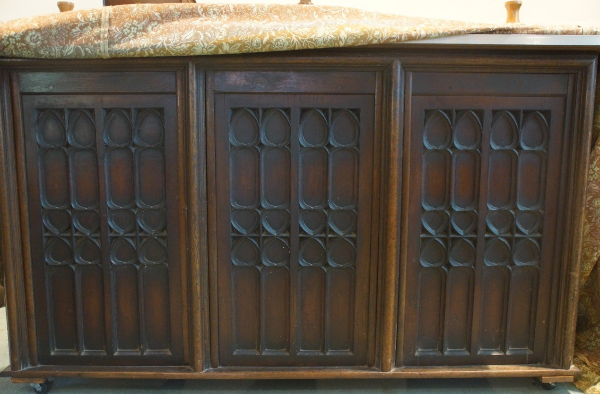  Existing Side Aisle Altar | 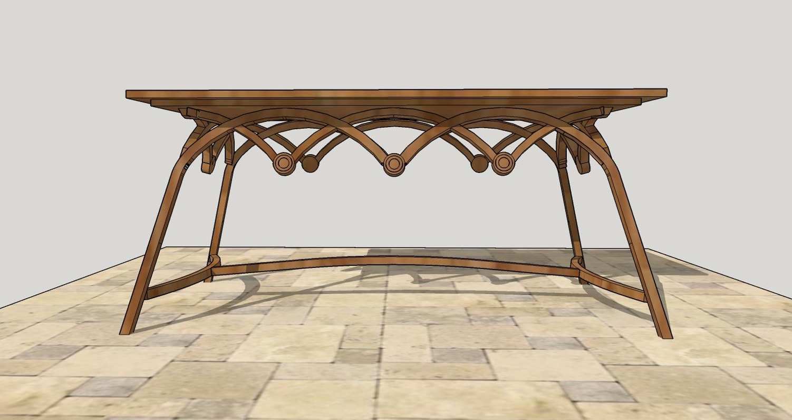  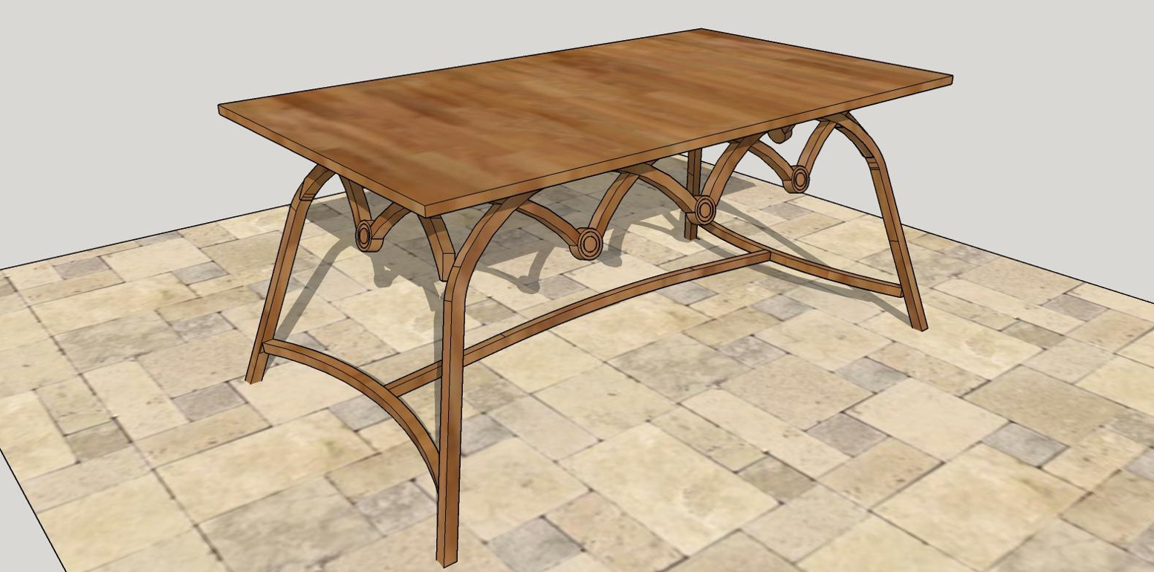  Proposed new altar

- Flooring: The floor is to be replaced by a wooden floor on a single level with the exception of the chancel which will remain a raised stone area. The flooring will be in light oak (or similar) with a finish which is sympathetic to the Grade II* listed building.

- Organ: A second-hand organ, originally from Bibury Church in Cirencester, (dating from 1868) was rebuilt in the tower arch in the 1960’s and is considered to be of low significance. The organ pipes block out the west window and the light that comes in from it. We believe the organ should be removed and replaced with a modern electronic organ (i.e., the Makin organ from Church Organ World, Manchester) with a wooden casing that matches the new church floor and altar.
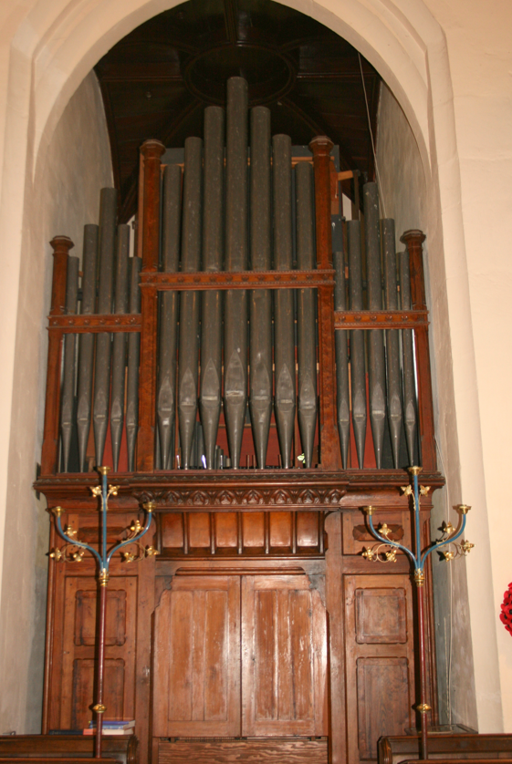  Existing Organ | 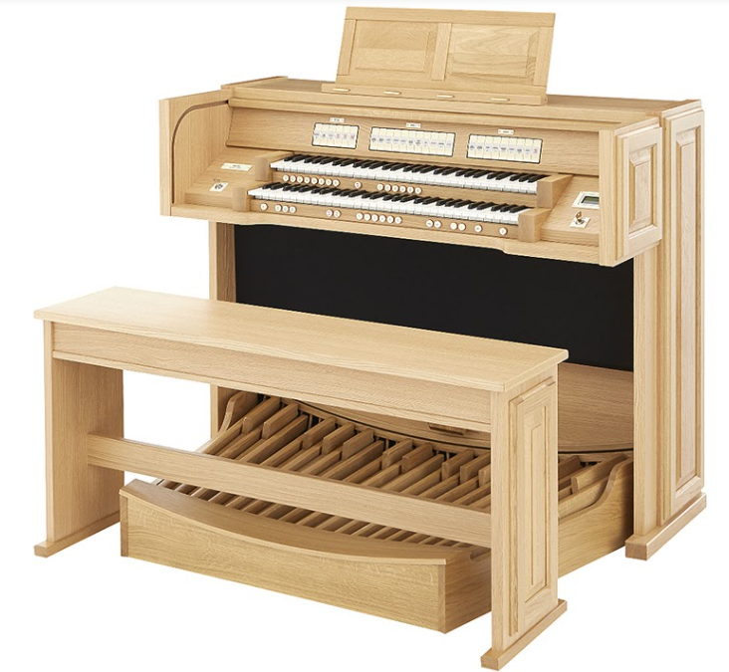  Proposed new organ
- Servery: The space resulting under the tower, from the removal of the existing organ, would provide an ideal location for a kitchen/servery. It will be used for warming and serving food, rather than cooking meals from scratch, so will only need a recirculating fan to deal with the minimum amount of smell from the food. A fridge, induction hob and oven are required to reheat food. The servery should have a folding door/screen and a drop down counter to serve food/drinks from. The servery should have an oak finish.

- Lobby: There is a pair of very fine historic oak doors leading into the church, but the existing internal lobby detracts from their setting. A larger and accessible lobby is proposed to replace this with framed glass doors to allow in more light, retain the heat, while presenting the historic doors better while being more welcoming.

- Vestry: the vestry will be maintained at its current location most of the existing cupboards will be removed so that it can used as an extra room. A glass partition is to be added above the vestry door leading to the Church to retain warmth and reduce sound in and from the Vestry area. This will allow the vestry to be independently heated and used by small groups.

- Accessible WC: A single access, fully accessible WC to be located in what is now the Creche area. This will provide us with 2 WCs in total, with one easily accessible from within the church.

- Heating: Underfloor heating and new convection heaters are to provide a better quality and more even heating. The system will be future proofed so that when the existing boiler becomes obsolete the system can then be easily adapted to use an air source heat pump in the future and further reduce our carbon footprint.

- Pulpit: Pulpit to be retained for now, or parts of it used elsewhere in the church.

- Storage: A storage room to store up to one hundred stacked chairs and storage elsewhere around the walls where appropriate for other items e.g., tables, books, candles, toys. All storage will be finished with timber using a colour and finish sympathetic with the flooring.

- Projector and Screen: The existing projector and screen should be retained in their current position and the spare screen added to the north wall.

- Church Exterior: We do not envisage any changes to the outside of the church although a small vent for the WC will mean we will need to apply for planning permission. Drainage from the WC will be located under the existing modern path minimising disturbance of the church yard.

Proposal to couple the reordering with the Nave Roof repairs

In January 2020, our Church Architect advised that the nave roof will need major repairs within the next 5-10 years. It is estimated that this will cost around £250,000 and require the church to be closed while repairs take place. As both the roof repair and reordering require the church to be closed while construction takes place it makes sense to carry out these two projects concurrently. The two projects are complementary as repairing the roof leads to consideration of the future use of and function of the church and there is little point to our reordering without the roof being sound and waterproof.

While we will fundraise concurrently for the Nave Roof Repair and Reordering projects. People will be able to elect to donate to the Roof Repair, the Reordering, or to both projects. We will be guided by the architects on how the construction elements of the two projects can be managed over the same time period.

The proposed layout for the reordering is shown on the following pages.

NB the illustrations of chairs were provided by our architects to illustrate how stacked chairs would look not indicative of the chairs we will be having. We are not at the stage of choosing chairs, we will carry out all that any good architects and the DAC suggest so the chairs will match the floor and altar. This application has received preliminary acceptance. However, for our launch in March 2022, we will provide examples of the Theo Chair and the likely flooring.

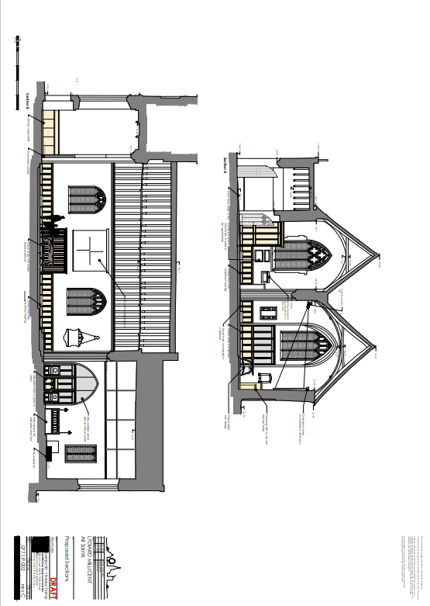
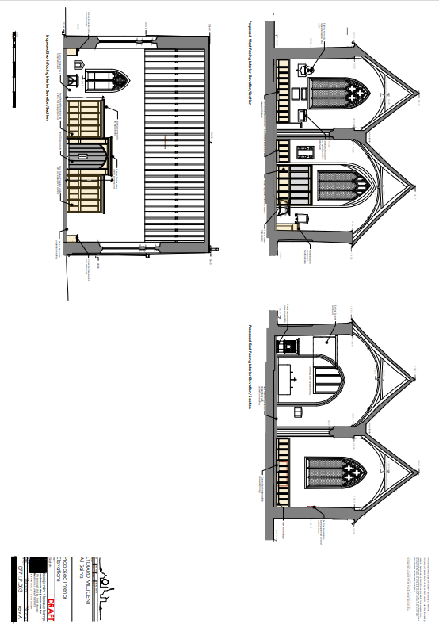
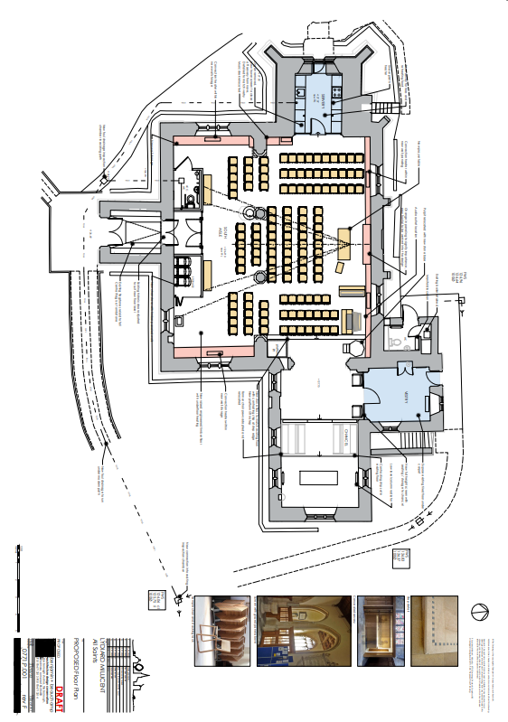

Why do you need it and why do you need it now?

All Saints Church Lydiard Millicent - Why reorder the interior of this wonderful church building -Tudor Vaughan Roberts

Can you recall a wow moment when you walked into St Pauls Cathedral or Cardiff Arms Park or the Sistine Chapel in Rome, something about these buildings caught your heart and emotions and you said “Wow!”. Now All Saints is situated in a village, it is not anything like the buildings I just mentioned. But we, those who have the reordering on our hearts, have equal enthusiasm to see this building reborn to be fit for the 21st Century whilst retaining all that is historically brilliant.
We can do many things in the building now and we are, we hold services on Sunday and mid-week, cafes for all, youth groups school visits big festival services when a hundred plus people pour through the front door. But we want, we desire, we yearn to do more, and do it intelligently and with forethought.
Our core reason for our existence is to proclaim the Gospel of Jesus Christ and do this in a building where people can sense the presence of our Transcendent God, pause, pray sing meet learn to do all these things as we worship the triune God. Yes, you can do all the above outside in God’s creation, but in England, history shows that buildings work best. We shelter in God’s ark under his wings and together we build the church.
My vision is that mid-week we have ample opportunity to run after-school services and drop-in gatherings. Located opposite the Car park where parents gather, we are not a church on a hill, we are bang in the middle of the Community. So, let us tell a story, a story to come.
Lydiard Millicent September 2022 and it is Monday 3.20 pm. Children pour in and are served drinks and refreshments from our new kitchen, then they gather at the front of the church, sitting on the comfortable wooden floor, all the chairs pulled back but enough out so parents can sit down and take a deep breath after walking down from school. Quite naturally the worship starts for a short half-hour service. Light pours in from the window where the organ used to be. Without needing to ask, those that need to, and parents and grandparents can get extra drinks from the kitchen, which is light and airy, or use the new toilets in the crèche area. The building is light warm and safe, the musicians have a choice; they can use the new stand-alone organ, or the piano or the drum kit there’s room for everything. A number of children wander up to the front and pick up percussion instruments. There is space for everything, including display boards, which we now have room for, where the kids post their crafts. “That’s mine, I did that,” says jack and Avnish his friend cannot wait to add his too.
At the end of the session, the children and parents all walk out happy at having accessed church in the week. One of the older parents stops afterward to talk to a Kidz’ club team member and someone else with the Vicar. Both find the quiet of the Chancel wonderful for this and everyone is glad they have kept this part of the old building.
As that session finishes, a new team comes in and gets the church ready for the community cafe meeting the next day. Jenny says, “leave some space at the front won’t you, the Christian aerobics group come in before the café remember”. ” Yes, sure thing” this church is buzzing’s but all pitch in and get everything ready, but before going Jenny stops at the old altar and prays, “Lord Thank you for what you have done in our amazing new building, please touch each person who comes in here tomorrow.”
Before everyone knows how the week has gone, Sunday has come and nearly all the chairs are put out ready. “So glad we bought these chairs” says John, “They stack well and are light to move.” Children and adults pour in for the main morning service. Many say how brilliant it is, with the church brightly lit and space to meet and chat and welcome newcomers. Wheelchairs can easily move around and there is space for people to park buggies at the back. But above all it’s not “things that matter,” people all say they sense God’s presence more easily, the hung banners, the light coming through the windows, the position of musicians so all can see them, and they can see us. There seems something about our church now, it is so much more welcoming to all. “The Lord be with you,” says the Lay Leader “Wow that was quick!”. That is the end of the service, time has whizzed by, and the youth worker organizes everyone to get the chairs put back, tables are put out and everyone gets ready for one of the bi-monthly Sunday Lunches in church, “Yummy” everyone says, “Roast Beef and nut roast can’t wait.” A family wanders in from outside they had heard the happy hubbub. “Can we join you?” they say. “Of course, come on in, welcome to our new church".
“You meet here on a Monday for an after-school service,” says the young 8-year-old in that family “Can I come”?
“You have an aerobics group meeting before the café on a Tuesday,” says Suzie’s Mum “Where can I sign up?”
“You have a Men’s shed group that meets here on Saturday mornings,” says the dad Ted, “Count me in.”
The new young Curate hears it all, must get on the phone Revd Tudor on holiday in Wales, and must tell him and Tricia how all his dreams came true! “I told you” says Tudor “It’s better than Cardiff Arms Park, better than the Sistine Chapel, better than the new McDonalds in Bristol. Its the New All Saints church centre coming Tricia’s “mine’s a Welsh cake.” “Yes,” says Philippa the new curate “Praise God the team had the vision to reorder All Saints.” Just then light in the shape of a cross pours in from the organ window. Thank you, God, that is my wow moment, for today. God is in this house.
C. Tudor Vaughan Roberts 2019 Trinity 14

Financial Position

We have an initial budget of £45,000 to enable us to progress the project through feasibility, concept, and design. We appreciate that the costs associated to deliver the project are likely to be sizable. We envisage that we will raise funds via our church Membership and grant-making authorities.

Justification

We believe that our proposals are key to delivering our vision; Be Family, Make Disciples and Serve others. Without the proposed changes we will struggle to grow our church which inevitably will lead to decline. Some indicative examples of the challenges we will struggle to overcome without a reordered church are:

- Accessibility. The Pews are difficult to use for those with any physical disability or restriction. Entrance to the church is narrow and hard to negotiate, particularly for those in wheelchairs and there is no accessible church indoors.

- Extending the use of the church is almost impossible. Pew layout limits our ability to run smaller, less formal groups such as Alpha. Important community events, such as providing meals are severely restricted by the pews with us having to erect temporary tables and seating the naïve and aisles. Schools are used to working in more flexible teaching environments, therefore making the church a challenging place to deliver modern lessons/learning using a variety of teaching methods and technology. Our pre-school group, Millicent Minis, also had to be held in the Village Hall. A reordered church would bring many of these events back to the church, building stronger bonds and fostering a more positive relationship with the community.

- The lack of a servery also causes several limitations. As well as serving meals, mentioned above, various lunch clubs and our regular Men’s Breakfast are forced to use Village Halls or the Vicarage. As per the points made above, inclusion of a servery further extends the role of the church.

Explanation Notes.

The Altar/Holy Table.
We have taken the opportunity to commission a new one, (altar/holy table) that will include in its design inspiration from the Font and or the Arched roof. Also, we do feel it would be a great opportunity to have a table that would be a focus as people come in The Font, Altar and possible lectern would be of a design that would match each other. This new movable altar will allow flexibility and creativity around how we run our services’ places against the North wall, not only will provide an immediate focus for these coming into the church, but it will also allow us to run larger services where everyone can easily see the altar and the Minister. The altar in the Chancel will remain for more intimate serves and some weddings.

Why seek to move the Organ and put in a servery?
Because doing this will free up the window behind the organ and allow light to flood the west end of the church. The space freed up would allow a servery of sufficient size to be put there and it would be easy to put in water and pipes running along the path and down to the road with no need to make changes to the outside of the building. Placing the Servery in the Belltower means that people coming and in and out of the church would not be blocked by people drinking coffee. The fact that the servery is a separate area, which is well lit from the newly revealed West window, and which can be accessed from the back, means that health and safety risks are significantly reduced.
We looked at placing the servery in the vestry and in the church on the left as you come into Church, but the Planning Group was unanimous in seeing that the Tower is the best place to put it.

Why move out the Organ, surely this is ecclesiastical iconoclasm? #

No, it is not. Firstly, we believe that moving out of an organ and finding a good home for it is a smart move. The cost of maintaining the present pipe organ is very high and we wish to be wise stewards of the financial resources we have. Our existing organ was installed second hand from a church in Bibury, in the 1960’s. This will be recycled and replaced by a modern Organ. Modern organs can produce a depth of sound of a traditional organ. All three of our musicians are fine with our decision to move out the organ and locate all musical instruments in one place to the right of the renewed Church. We anticipate some objections but believe our arguments are solid.

We think we can find someone who will take and remove the organ, it is not of significant historical interest such that its removable should be of any issue to the Victorian Society, English Heritage, or any other relevant conservation Body. The organ was only installed in our church in the 1960s so it cannot be said to be an integral part of the historical building of All Saints, and there is no just cause or impediment why it should not be removed. This has been done in many other Grade 2 listed buildings like ours. Already one company in Yorkshire has indicated they might have a buyer in Bavaria but not confirmed that yet. A Malta-based company for about 4K will move out organs.

The space freed up allows to put in a servery without doing outside building work. The tower has a door albeit a short one to the outside which does allow entrance and exit without using the other doors in and out of the church.

The organ is listed on the National Piped Organ Register (NPOR) and is not considered to be 'historically significant,’ and we have contacted the original builders, who also do not consider It to be of any historical significance. We would like to highlight that maintenance costs for the organ are likely to be significant in the near term.

Why put a toilet in what is now the creche area the church?

A fully accessible and sound proofed lavatory will be installed in the south west corner of the south aisle in the Crèche area. This Is in addition to accessible lavatory outside the Church behind the vestry.
It is a very clever place to put it. People can easily access from within the building, and we can put in sewage and water pipers from the pathway outside the Church with minimum disturbance.
This is need in addition to the existing lavatory, for those who would find walking to on the pathway around to the back of the Church challenging and young children no longer need to be escorted around the building reducing the numbers of adults needed to run activities. It is also far more convenient when its dark and cold.
Our architects advise us that small ventilation outlet vents are needed for the toilet and may also need planning permission. The vent cover is to be a black metal louvre and will be sited in a discreet location.

Why seek a to have a new floor put in and remove the pews?

Apart from a very few people most people find the pews very uncomfortable. We believe if we do not put in a new floor then we will soon have to in the very near future. The current carpet is not in sympathy with the building (according to the DAC) and need’s replacing and the floor underneath it is not secure, even if we did not do a reordering. As said elsewhere we believe a new floor with new chairs all sensitively and tastefully done will mean that we have a space that allows worship and provides a space for other activities. Underfloor heating plus new radiators will enable us to efficiently heat the building and give added heat when needed.

As a total project we truly believe that the changes we are seeking enhance present architecture and features, enable worship and mid-week activities to be done in a much more imaginative way and moving the font, putting in a new floor, adding a toilet etc will, once it is done, will really help All Saints to be ready for all that the Church and community wish to use this unique building for now and well into the future. We are open to advice and welcome it, but both architects and planning for reordering committee and Vicar believe that our homework thus far means we have a very workable and feasible plan that we can very soon take for a faculty for reordering. Our Archdeacon the Ven. Christopher Bryan has looked at what we have done and is also broadly supportive thus far.

Additional general point to consider
We are seeking to make the above changes because:
- the current accessibility is limited due to the steps at all points of entry to the church building and restricted (external) toilet facilities.

- A bat survey has been completed as part of our chancel roof restorations and although bats have entered the building previously, none were found when the Chancel roof tiles were removed prior to being repaired and replaced and there was no evidence of their residence in the building. Bat roosting boxes have been constructed in an adjacent property and a copy of the bat survey can be supplied on request. A new bat survey will need to be completed for the Nave roof repair. We have already had a quote for this.

- We have a small amount of money from a legacy to kick start this project and like other churches, we would seek to get funding from grant-making bodies and trusts and seek the involvement of church and wider community once the project has been shared with them. We have successfully raised £121,000 for our chancel roof project which is now completed and this fundraising was completed in under 12 months.

